
Year 10A Practice Exam

Finance and Trigonometry

      - [6 marks: 1, 1, 1, 1, 1, 1]
Circle the correct answer.
a. | Find the simple interest on $1500 at 8% p.a. over  4 years.  A $360 B $480  C $600 D $720 | b. | Find the growth factor for 6% interest, compounded annually.  A 0.06 B 1.06  C 0.005 D 1.005
c. | If Jennifer borrows $2000 and has to pay back $2400, what is the percentage rate of interest?  A 1.7% B 20%  C 40% D 120% | d. | What is the value of tan 180°?  A 0 B 1  C −1 D Undefined
e. | In the triangle below, which ratio represents sin θ?  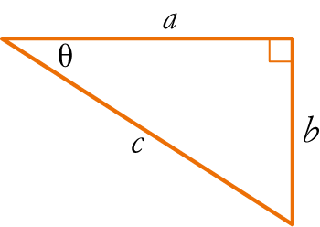  A B  C D | f. | What is the angle a a measure of ?  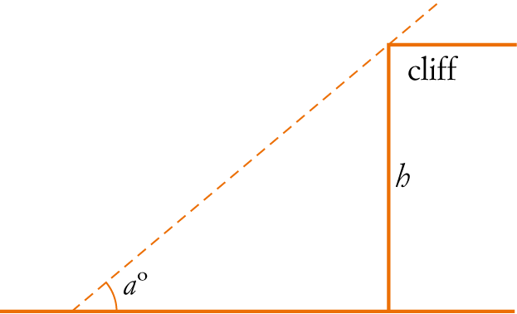  A The angle of elevation  B The angle of depression  C The line of sight  D The gradient

      - [1 mark]
How much will you receive if $10 000 is invested at 12% interest, compounded annually for 6 years?

      - [7 marks: 2, 2, 3]
Find the size of the unknown quantities. Round to 2 d.p.
a. b.
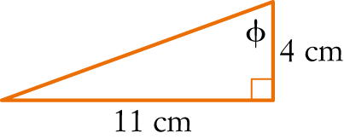
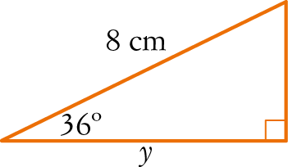

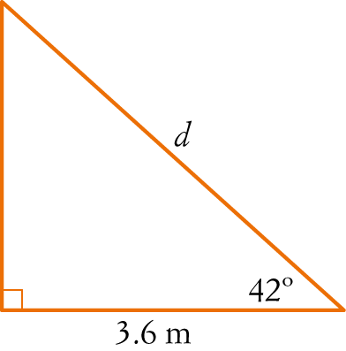
c.

      - [5 marks: 1, 2, 2]
Bert borrowed $1200 until pay day 3 weeks later, when he had to pay back $1290.

a) How much interest did he pay?

b) If his loan was for a year, how much interest would he have to pay at the same rate?

c) What was the per annum interest rate?

      - [4 marks]
A certain savings account pays 2.5% on minimum monthly balances. Find the interest earned in the following 6 months if the balances are shown in the table below.

Month | Jan | Feb | Mar
Balance | $245.24 | $302.56 | $128.12
Month | Apr | May | Jun
Balance | $250.30 | $276.80 | $428.11

      - [7 marks: 1, 1, 1, 4]
Mark has been saving his money, so far he has $5500 saved up. He plans to continue saving for another two years and then spend the money on a new car. He decides to invest the $5500 in a term deposit for the two years, so that he can earn some interest on his money. He needs to choose one of the following banks:

BSC Bank - pays 2.5% pa interest compounded annually.

MD Bank – pays 2.45% pa interest compounded quarterly.

RP Bank – pays 2.4% pa interest compounded monthly.

By calculating the amount of interest he will earn, decide which bank Mark should invest his money with?

      - [2 marks]
A flagpole broke in a storm. 7 metres are still sticking straight out of the ground, where it snapped, but the remaining piece has hinged over and touches the ground at a point 24 metres away horizontally. How tall was the flagpole before it broke?

      - [2 marks]
Adam, who is 1.8 m tall, holds up a plank of wood 4.2 m long. Find the angle that the plank makes with the ground, correct to 2 decimal places.
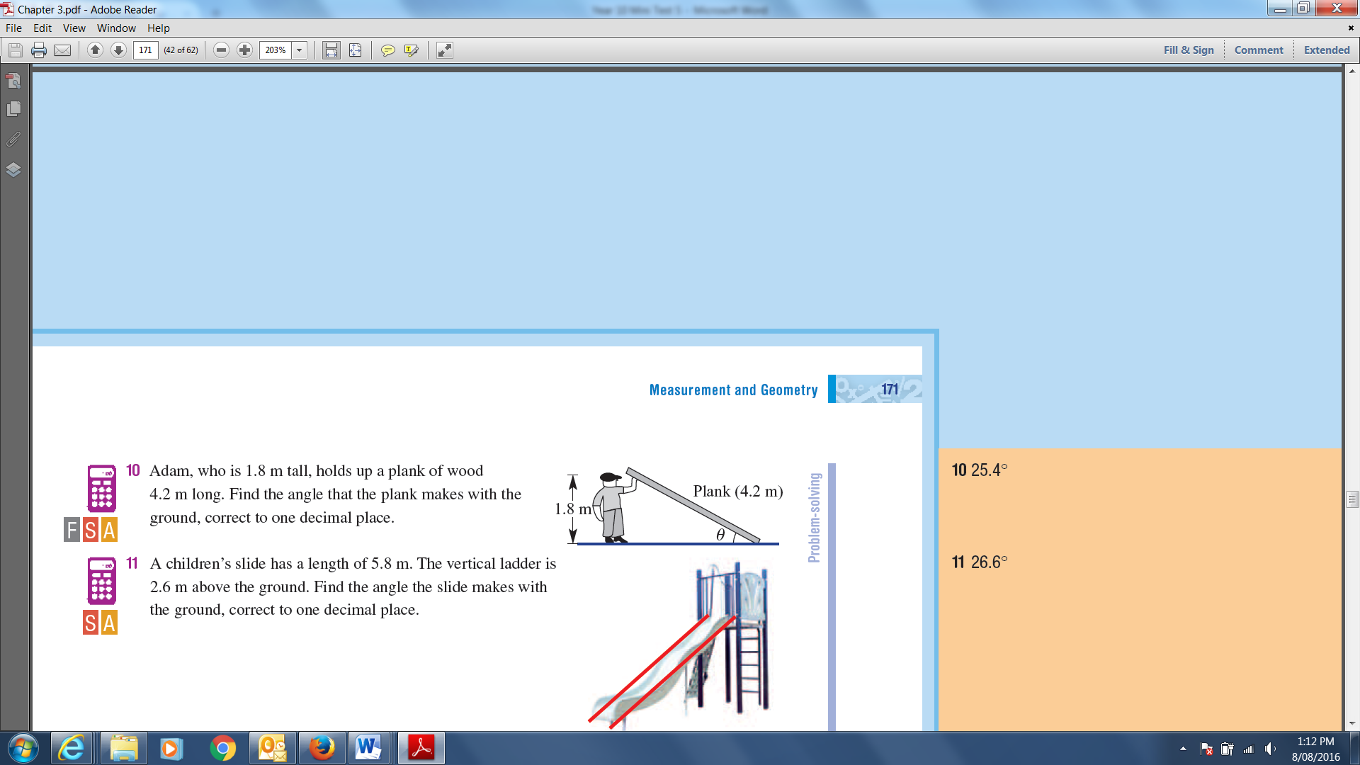

      - [3 marks]
When the sun’s elevation in the sky is 50°, a tree casts a shadow 2.8 m long. What is the height of the tree?
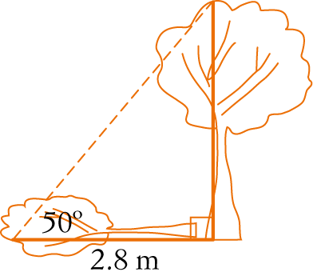

      - [3 marks]
An airplane takes off 183 metres in front of a 18 metre building. At what angle of elevation must the
plane take off in order to avoid crashing into the building? Assume that the airplane flies in a straight line and the angle of elevation remains constant until the airplane flies over the building.

      - [6 marks: 3, 3]
Electronic instruments on a treasure-hunting ship detect a large object on the sea floor. The angle of depression is 29°, and the instruments indicate that the direct-line distance between the ship and the object is about 427 m.
- How far below the surface of the water is the object?

- How far must the ship travel to be directly over it?

~End of Test~

